Invoice Generation Procedure
Over View:
O’Connor will invoice the property owners based on the terms mutually agreed by O’Connor and its Clients. Most of the cases, the invoice will be generated basis the property value reduction.
Scope:
Invoices will be generated based on the terms and the remarks of the accounts qualified for invoicing. Invoices will be queued only when the hearing is finalized.
Upon finalizing the hearing in the hearings tab/Litigation/Arbitration tab, invoices will be queued automatically as per its invoice type Standard, Litigation and Binding Arbitration.
Types of fees:
- Contingency
- Flat Fee
- Capped Fee
- Combination of all above fees
Contingency Fee:
- Fee will be calculated basis the tax savings obtained (i.e % of estimated tax saving) as mentioned in the terms.
- The default fee will be 50% and it may vary depending upon the property value/no of properties the client has.
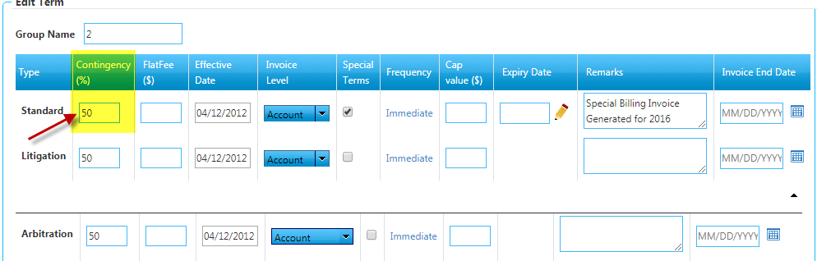
Flat Fee:
- An invoice with the flat fee will be generated irrespective of the tax savings. This fee will be applicable to accounts wherein we haven’t obtained a reduction as well.
- If we do not have contingency fee, we will generate the invoice with flat fee based on the remarks for that particular terms type.
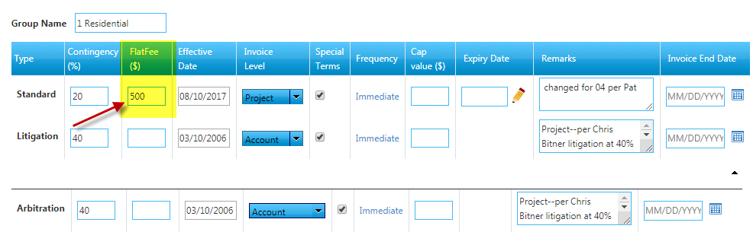
Cap Fee:
- This is applicable only for particular clients as per agreement.
- In this fee condition, the maximum billing amount will be agreed with the client and updated as the cap fee, (i.e., amount should not exceed the particular fee mentioned in the cap fee term) If the invoice amount is $5000 and the cap fee is $2500, invoice should be generated and sent to the client with the value $2500. Incase the (invoice amount as per the terms calculation is $1500, then the invoice will be generated and sent to the client for $1500). Whichever is lower condition.

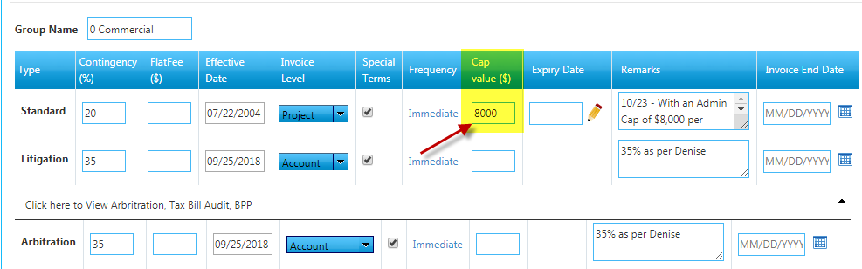

Invoices are classified in three levels :
- Account Level
- Project Level
- Term Level/Group Level
Account Level:
- Account level invoice will have only one account information in the invoice copy.
- The account will be queued for invoicing when the hearing gets finalized. In account level invoicing, the invoices are generated for each property individually.
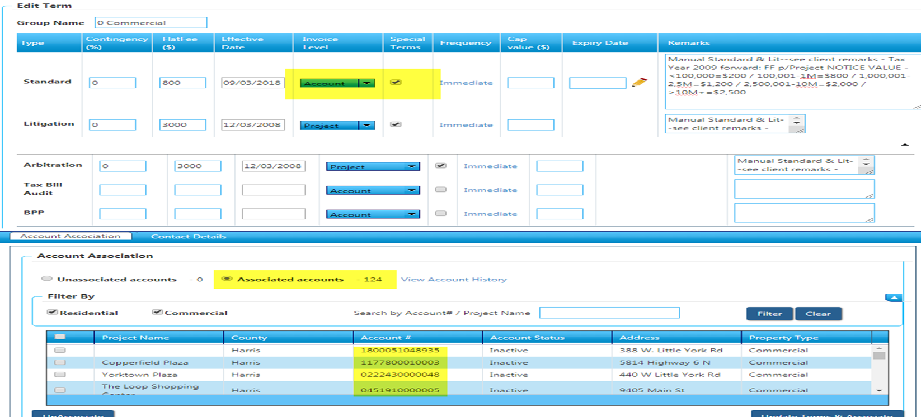

Project Level:
- Project Level invoice will have project name and corresponding accounts under the project will be displayed in the invoice copy.
- The records will be queued for invoicing only when the all the accounts under specified project has hearing finalized. Until then the record will not be queued for invoicing if it’s not a special queue.
- If it’s a special queue, then the project will be listed in the queue, however invoice will be generated once everything gets qualified.

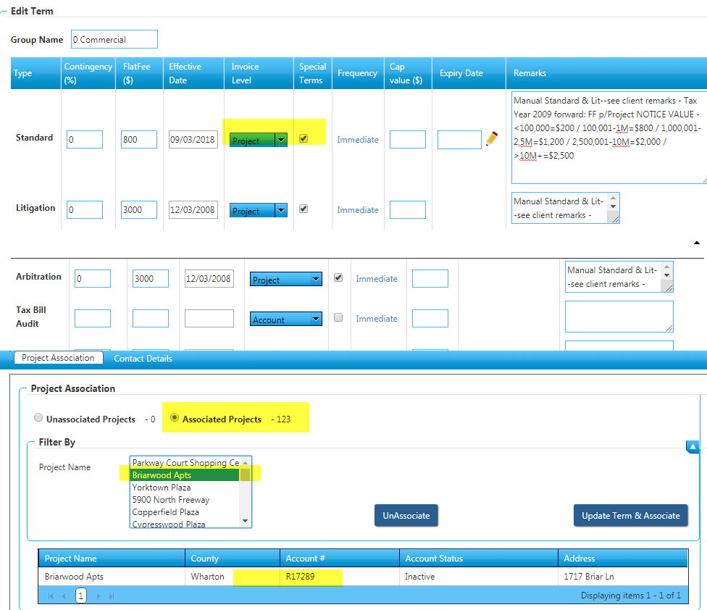

Term/Group Level:
- All the associated accounts will be listed in the invoice copy.
- The records will be queued for invoicing only when the complete accounts under the specified group gets finalized. Until then the record will not be queued for invoicing if it’s not a special queue.
- If it’s a special queue, then the record will be listed in the queue, however invoice will be generated once everything gets qualified.

BPP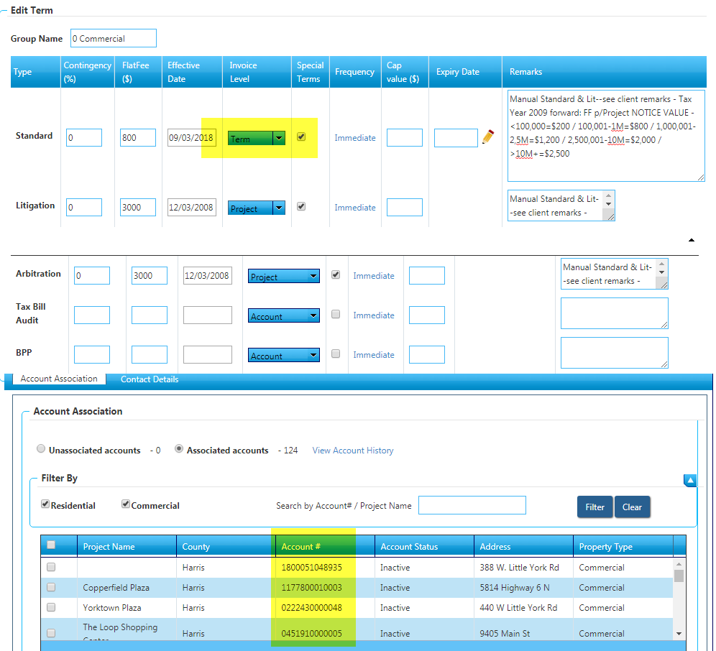
Spartaxx Invoice Queue Types:
- Standard Regular Invoice – Can be generated directly by previewing few invoice copies
- Litigation Regular Invoice – Can be generated directly by previewing few invoice copies
- Arbitration Regular Invoice – Can be generated directly by previewing few invoice copies
- Litigation Defect Invoice – Validation will be done
- Arbitration Defect Invoice– Validation will be done
- Standard Special Invoice– Validation will be done
- Litigation Special Invoice– Validation will be done
- Arbitration Special Invoice– Validation will be done

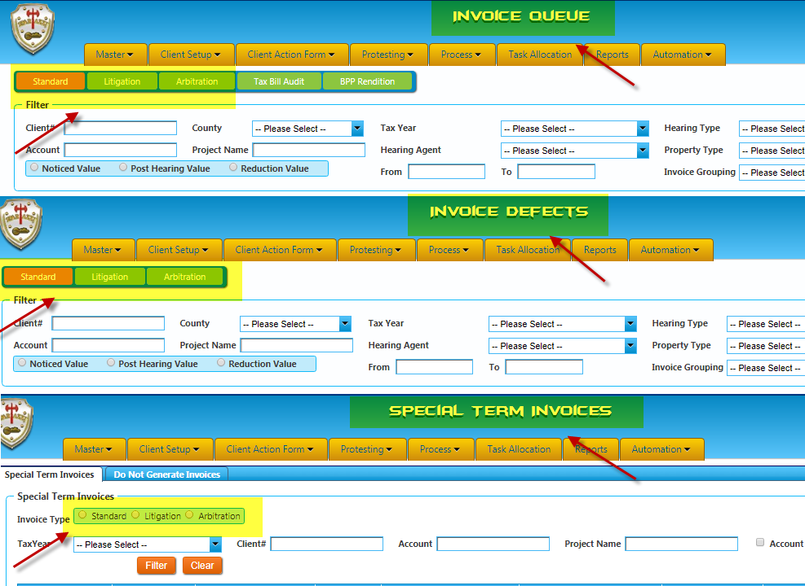

Steps followed for Standard regular Invoice:
- The standard invoice is generated for all client with a reduction in the Formal/informal hearing/basis the flat fee for the account.
- During the invoice generation, we validate the contingency %, tax rate, jurisdictions, value and the reduction obtained for the property and hearing finalized date & status.
- Invoices will be considered as not qualified if the invoice amount is “< $5” and the invoice will not be generated.
- Invoices are sent based on the remarks mentioned in the terms section.
- Invoices can be generated for single/multiple accounts at the same instance by either selecting single invoice/multiple invoices using the check box.
- When we click on “Send Invoice now” option, the selected invoices will move out of the invoice generation queue and will be available in the “Corr-Queue”.
- When the “Corr-queue” services run, the invoices are sent to the client basis their default delivery method.
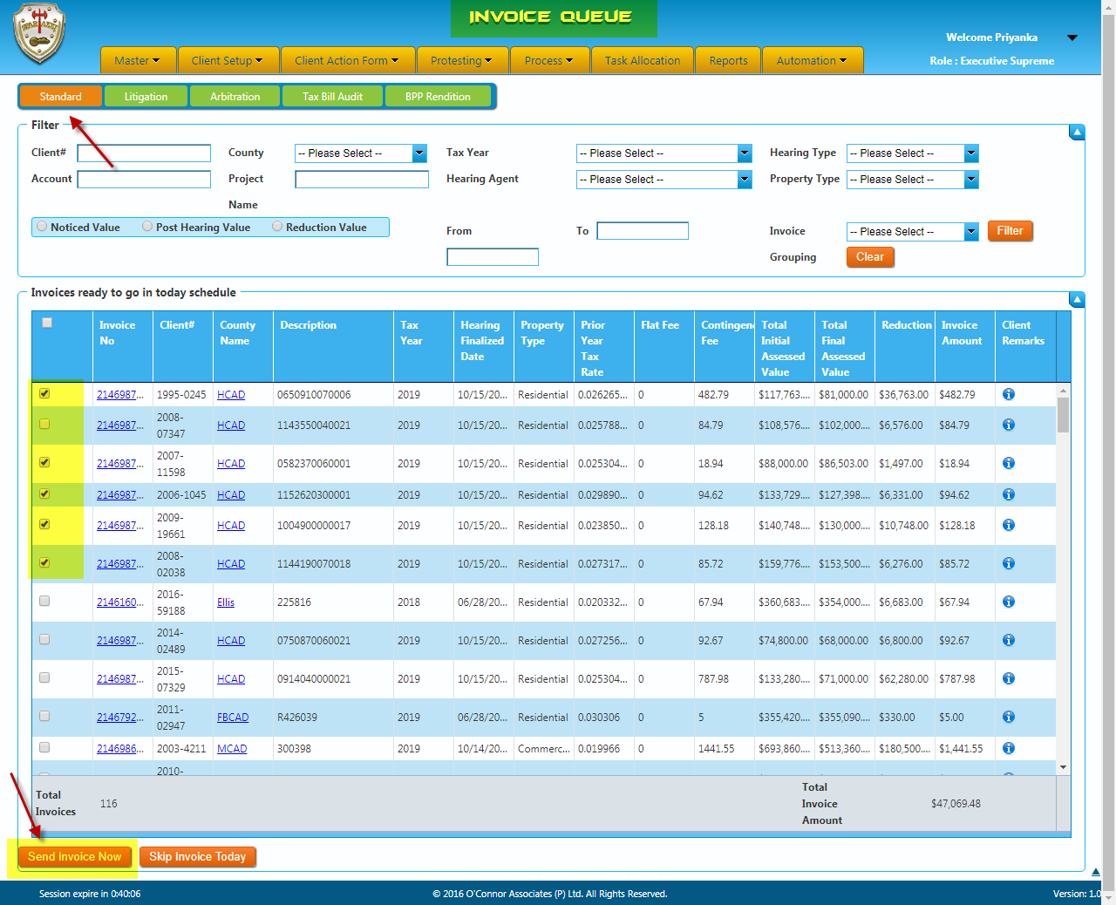

Steps followed for Litigation Regular Invoice:
- Litigation invoice is generated for all client with a reduction in the litigation hearing/flat fee for the account.
- Litigation invoices are queued as soon as the Litigation hearing is finalized.
- During the regular invoices for Litigations, we validate the Litigation Status, Settlement date, HR invoice status, contingency, tax rate, flat fee, remarks, values and prior year invoice details.
- Invoice will be considered as qualified only if the litigation status is “Settled, EXP - Settled”.
- If the litigation status is “Pending litigation, To be filed, No litigation Filed, Dismissed, No suit, EXP – Settlement in progress”, the invoice will not be considered as qualified and the invoices for those accounts will not be generated.
- If the accounts are qualified for invoicing, the invoices will be generated as like as Standard regular invoicing.
- The multiple accounts selection option is available for all the regular invoice generation.
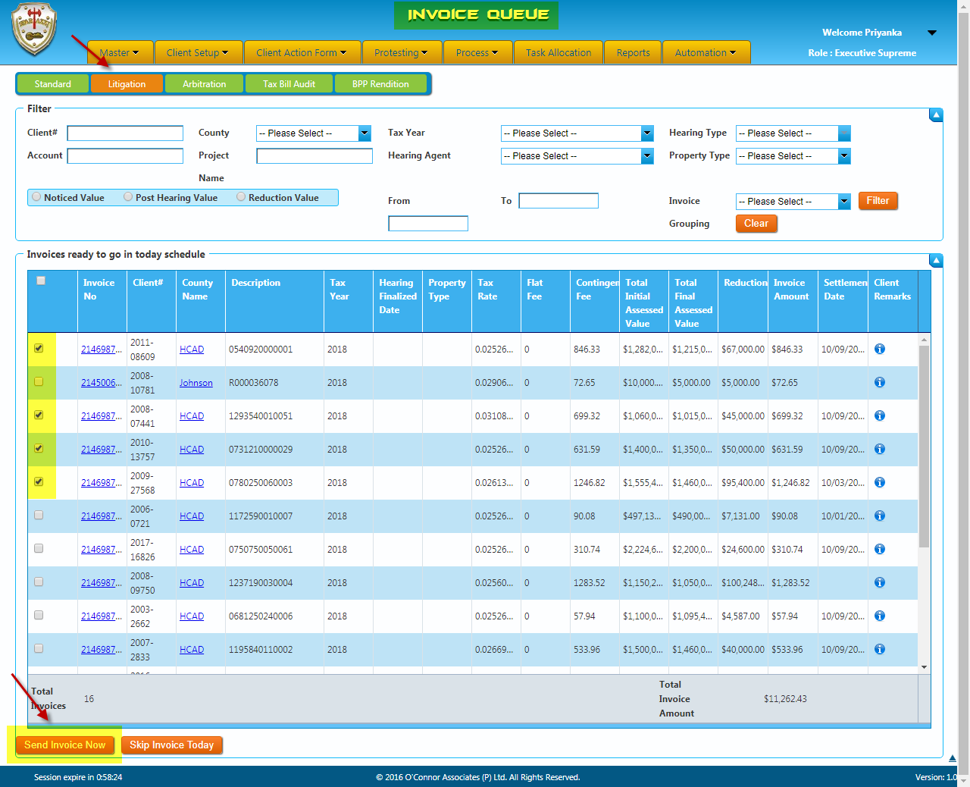

Steps followed for Arbitration Regular Invoice:
- Arbitration invoice is generated for all client with a reduction in the Arbitration hearing/flat fee for the account.
- Arbitration invoices are queued as soon as the Arbitration hearing is finalized.
- During the regular invoices for Arbitrations, we validate the Arbitration Status, Settlement date, HR invoice status, contingency, tax rate, flat fee, remarks, values and prior year invoice details.
- Invoice will be considered as qualified only if the Arbitration status is “Awarded (Won/Loss), Settled (Won/Loss)”.
- If the Arbitration status is “Pending, Withdrawn, Not filed, No show”, the invoice will not be considered as qualified and the invoices for those accounts will not be generated.
- If the accounts are qualified for invoicing, the invoices will be generated as like as Standard regular invoicing.
- The multiple accounts selection option is available for all the regular invoice generation.
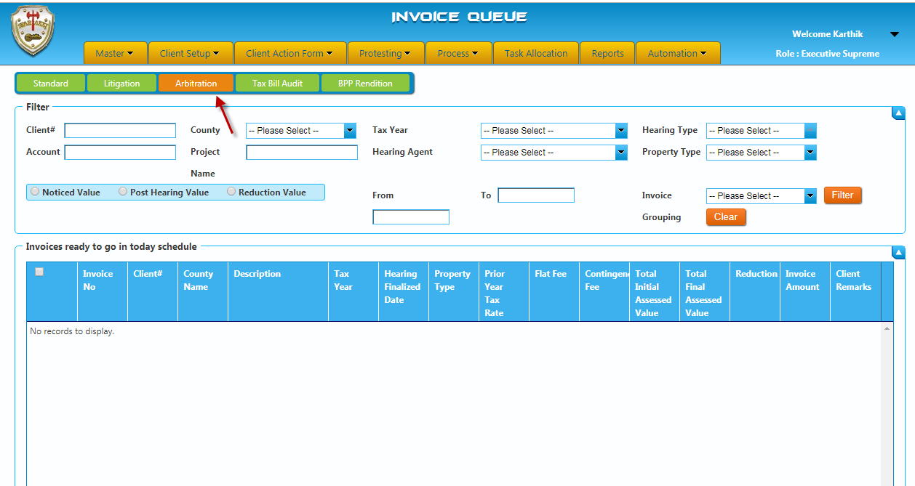
Steps followed for Litigation Defects Invoice:
- Invoice for the accounts wherein the tax rate is below 2.5% and those which has remarks in “Terms remarks” tab will be queued under this queue.
- As like as litigation regular invoices, we need to validate each status of the particular account and send from the queue.
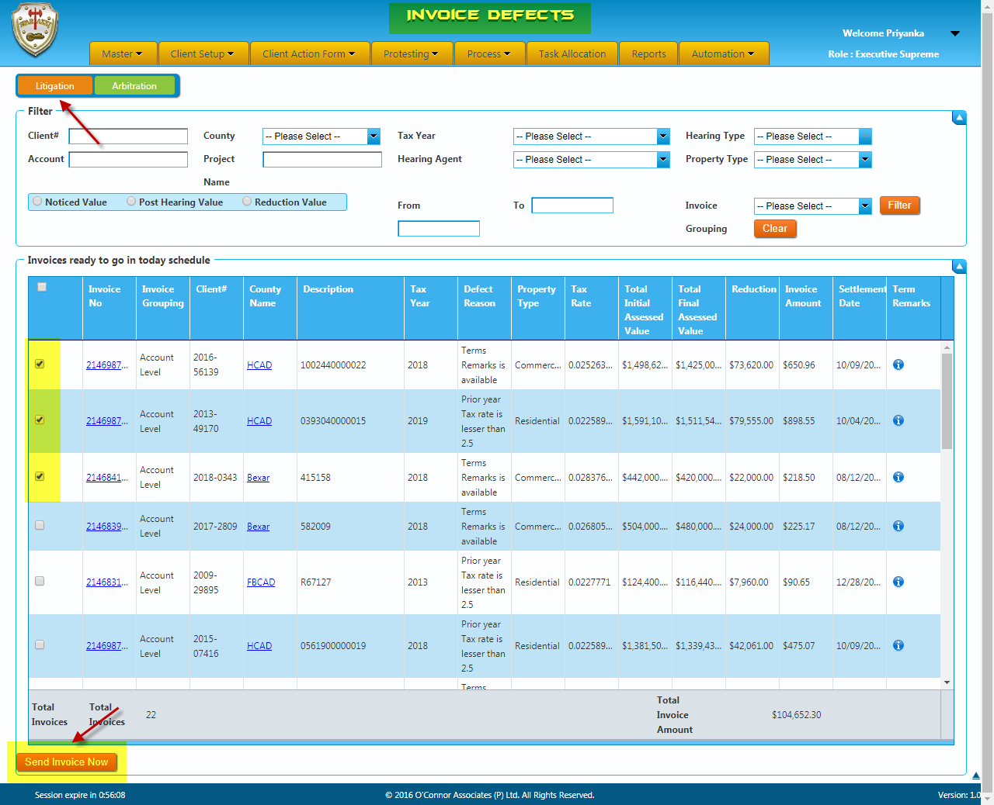

Arbitration Defects Invoice:
- Invoice for the accounts wherein the tax rate is below 2.5% and those which has remarks in “Terms remarks” tab will be queued under this queue.
- As like as arbitration regular invoices, we need to validate each status of the particular account and send from the queue.
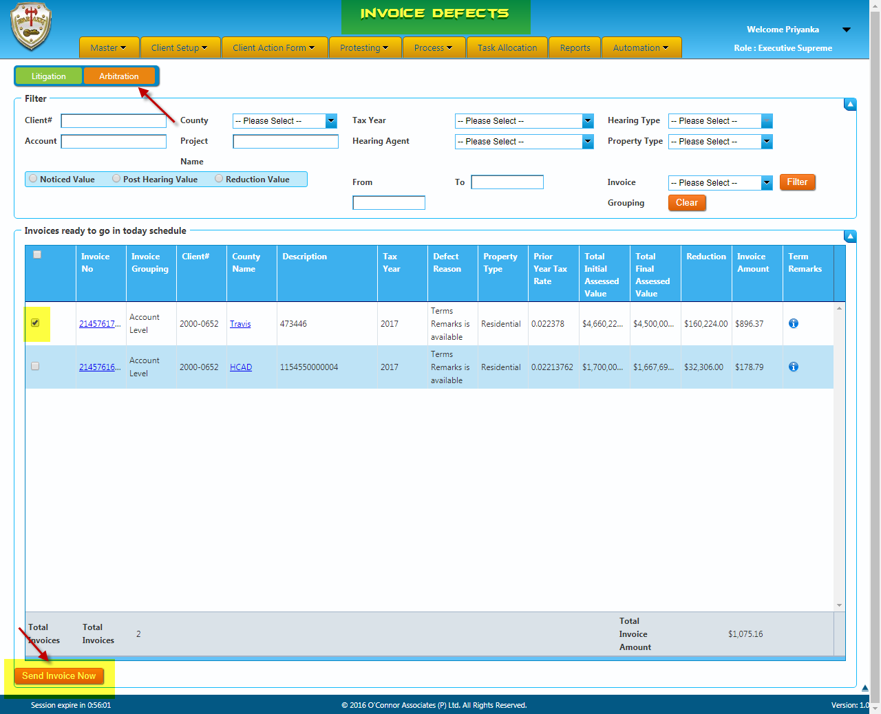

Special Term Invoice:
- The Accounts which are marked with “Special Terms” will be queued in the special queue.
- We will need to read the “comments” mentioned by the agent/consultant before generating the invoice.

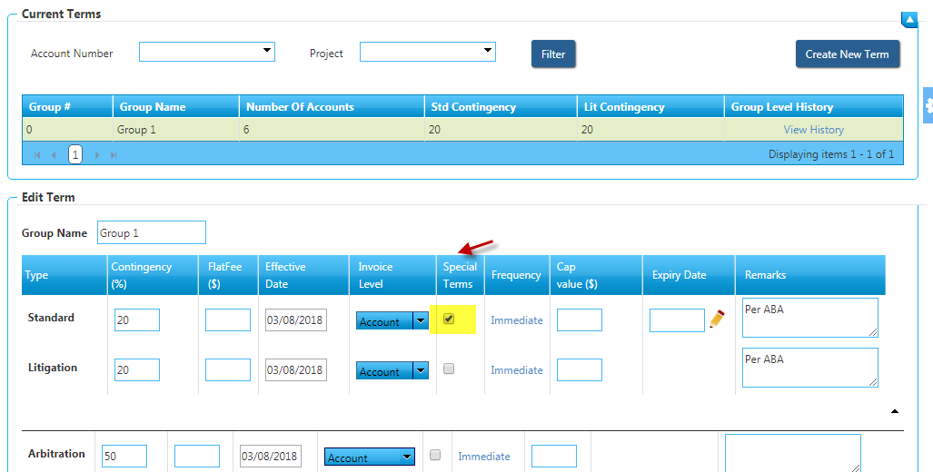

In special invoicing we have three methods of generating:
- Generate
- Do not generate
- Sent to Option using mail id “spartaxxinvoices@poconnor.com”.
Standard Special Invoice:
- Usually, special invoices will be applicabe for Commercial clients which has flat fee or cap fee at project level.
- In standard special invoice, we will validate the remarks in the codes tab (Client remarks), terms tab along with the contingency, tax rate, values of the property and the reduction for the property.
- If there is a flat fee mentioned for the account, it will be added to the invoice amount. For example: If the flat fee mentioned is $100 and the contingency fee is $1000 then the invoice amount will be calculated as $1100.
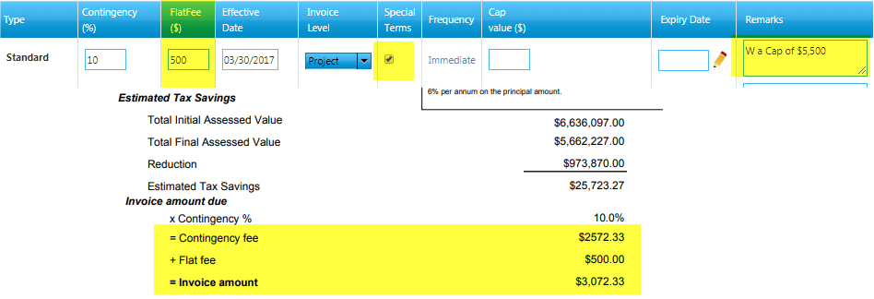
- If there is a cap fee mentioned for a particular account (eg: 5000, 7000 etc), invoice amount should not exceed the cap fee.
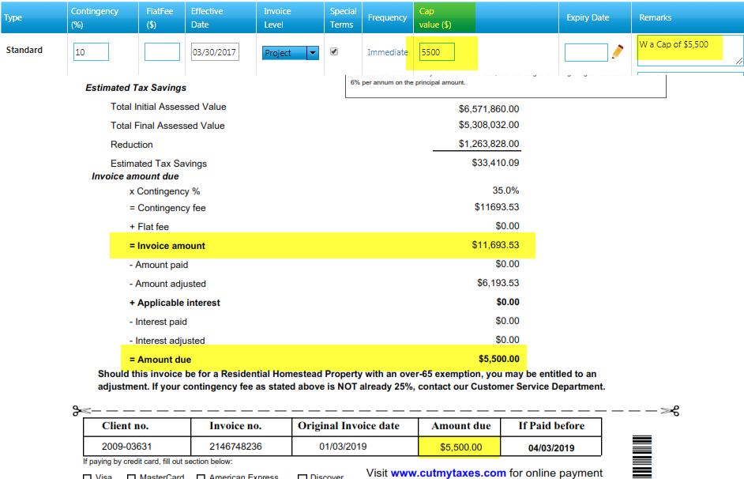

- Invoices can be generated only one at a time based on the invoice level.
- Invoice copy will be validated before sending the invoice from the queue
- When we click on “Send Invoice now” option, the selected invoices will move out of the invoice generation queue and will be available in the “Corr-Queue”.
- When the “Corr-queue” services run, the invoices are sent to the client basis their default delivery method.
- In special invoicing, even if the invoice amount <= 5 and contingency fees “0” invoice will be queued.
- Some category of invoices will be marked as “Do not Generate option” if the invoice should not send to the client.
- If the term remarks or the client remarks is noted as “sent to Denise, Denise will pull invoices”; invoices will be generated using “Sent to” option. Thereby the invoices will be sent to the email spartaxxinvoices@poconnor.com instead of the client’s mail id.
Litigation Special Invoice:
- Litigation special invoice is similar to the standard special invoice.
- In litigation special invoice, we will validate the Litigation status, HR invoice status, Contingency, Client remarks, Term remarks, Tax rate, Prior year invoice details, Values of the property and the Reduction for the property.
- Invoice can be generated for only one account at a time
- Invoice copy will be validated before generating each invoice from the queue.
- Invoices are sent based on the remarks mentioned in the remarks tab.
- If there is a cap fee mentioned for a particular account (eg: 5000, 7000 etc), invoice amount should not exceed the cap fee
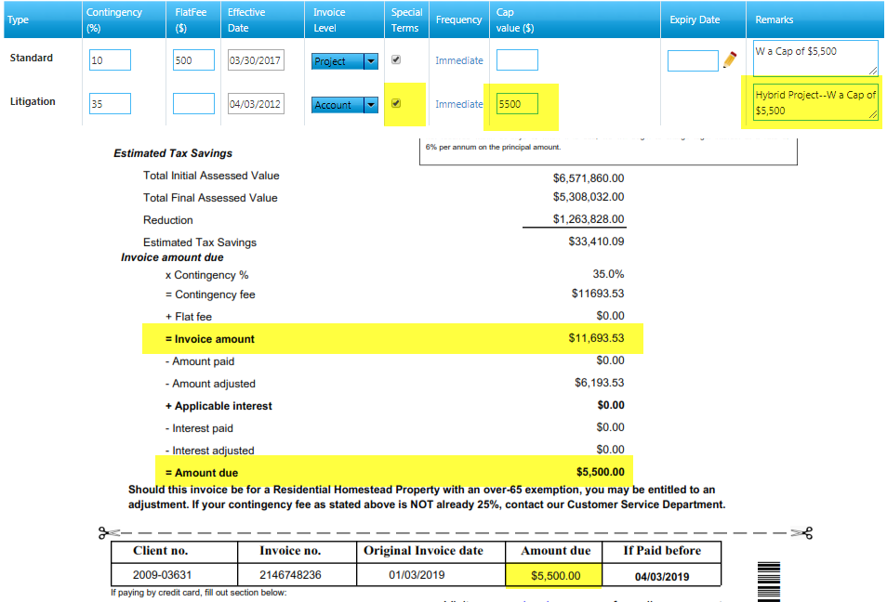
- When we click on “Send Invoice now” option, the selected invoices will move out of the invoice generation queue and will be available in the “Corr-Queue”.
- When the “Corr-queue” services run, the invoices are sent to the client basis their default delivery method.
- In special invoicing, even if the invoice amount <= 5 and contingency fees “0” will be queued.
- Some category of invoices will be marked as “Do not Generate option” if the invoice should not send to the client.
- If the term remarks or the client remarks is noted as “sent to Denise, Denise will pull invoices”; invoices will be generated using “Sent to” option. Thereby the invoices will be sent to the email spartaxxinvoices@poconnor.com instead of the client’s mail
- If there is any cap fee mentioned for a particular account (eg: 6000, 10000 etc), invoice amount should not exceed the cap fee.

Arbitration Special Invoice:
- Arbitration special invoice is also similar the standard special invoice.
- In arbitration special invoice, we will validate the Arbitration status, HR invoice status, Contingency, Client remarks, Term remarks, Tax rate, Values of the property and the Reduction for the property.
- If there is any cap fee mentioned for a particular account (eg: 5500, 9000 etc), invoice amount should not exceed the cap fee.
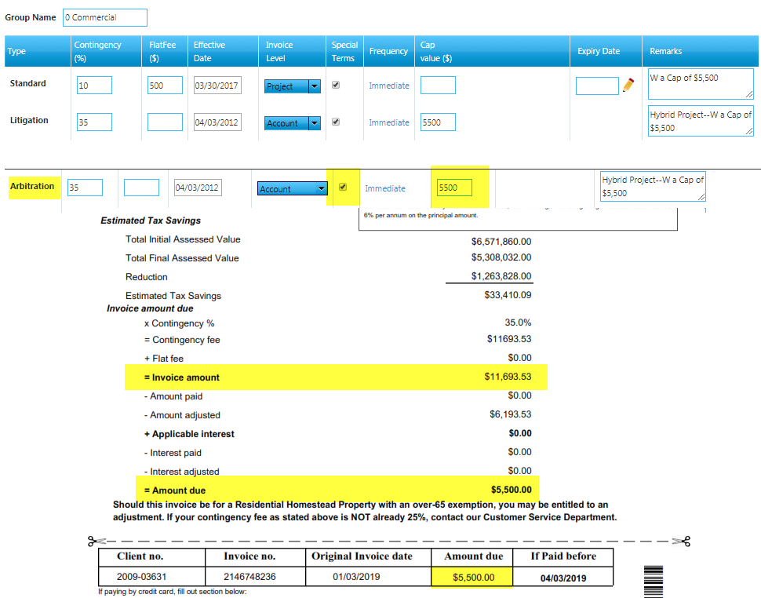
- Invoices can be generated only one at a time based on the invoice level.
- Invoice copy will be validated before sending the invoice from the queue
- Invoices are sent based on the remarks mentioned in the remarks tab.
- When we click on “Send Invoice now” option, the selected invoices will move out of the invoice generation queue and will be available in the “Corr-Queue”.
- When the “Corr-queue” services run, the invoices are sent to the client basis their default delivery method.
- In special invoicing, even if the invoice amount <= 5 and contingency fees “0” invoice will be queued.
- Some category of invoices will be marked as “Do not Generate option” if the invoice should not send to the client.
- If the term remarks or the client remarks is noted as “sent to Denise, Denise will pull invoices”; invoices will be generated using “Sent to” option. Thereby the invoices will be sent to the email spartaxxinvoices@poconnor.com instead of the client’s mail id.

Pending Group Invoice:
- All Accounts under the “term level” and “project level” must be qualified for invoicing.
- If all the accounts under the particular project or term level invoices are not qualified, those invoices will be moved under this queue until all the accounts under the term or project qualify; if it has not checked special terms check box.
- Once all the accounts are qualified, we need to select the particular account and select “Generate invoice” option to move the invoices to invoice generation queue.
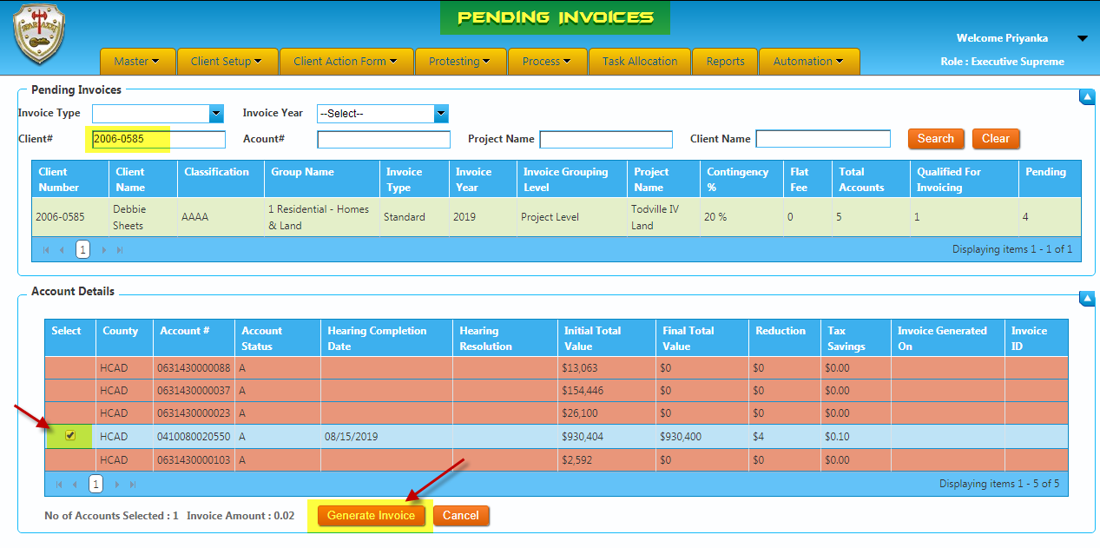
Calculation of Invoice Fee:
- The invoice fee will be calculated from the tax savings achieved after the Hearing.
Property value before Hearing | $500,000
Tax Rate | 2.512
Tax to be paid by the client | $12,560

Property value after Hearing | $450,000
Tax Rate | 2.512
Tax to be paid by the client | $11,304

Tax Savings | $1,256
Contingency | 50%
O'Connor Fee | $628

Sample Invoice Calculation

Particulars | Values
Notice Total Value | 1,575,688.00
Post Hearing Value | 1,000,000.00
Tax Rate (divided by 100) | 0.0534196
Contingency % | 50%
Reduction | 575,688.00
Tax Savings | 30753.02268
Invoice Amount | 15376.51134

- Invoice will be generated and queued based on the Invoice level set in the group associated for respective account number.
- Invoices are calculated by the values, contingency and tax rate.
- Invoice copy will be validated before generating the invoice from the queue.
- Invoices are generated based on the remarks mentioned in the terms remarks tab.
- If the client is over 65 we will consider the contingency as 25%. The other contingencies like 10%, 20%, 40% are applicable as per the remarks mentioned and 15% is applied for the lifestyle members.
- Invoices will not be qualified if the jurisdictions are blank.
- We cannot invoice the client, if the hearing is not attended by OCA.

BPP Invoice (Business personal property)

OCA is doing BPP Rendition hearings for personal properties which is being used for the business.
Usually, OCA will charge flat fees for BPP rendition hearing completed accounts to the owners.
The flat fee will be different for an account or based on the clients and flat fees list will be shared from Houston team agents with the excel format to Path finder team by client wise via Email.
The flat fees will be mentioned in the account associated terms under BPP row flat fee field as per the spreadsheet flat fee.
BPP Invoice will be generated for two types as follows.
BPP Invoice Types: -
- Account level
- Term level
Account Level: -
Account Level invoices are generated for single account which has only one personal property flat fee.

Term Level: -
Term level invoices are generated for more than 1 BPP accounts in the associated group.
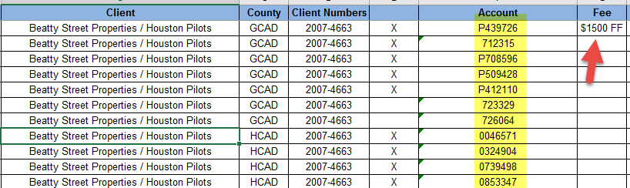
This will be mentioned in the list shared by the Houston team.

Flat Fee Terms - Account Level: -
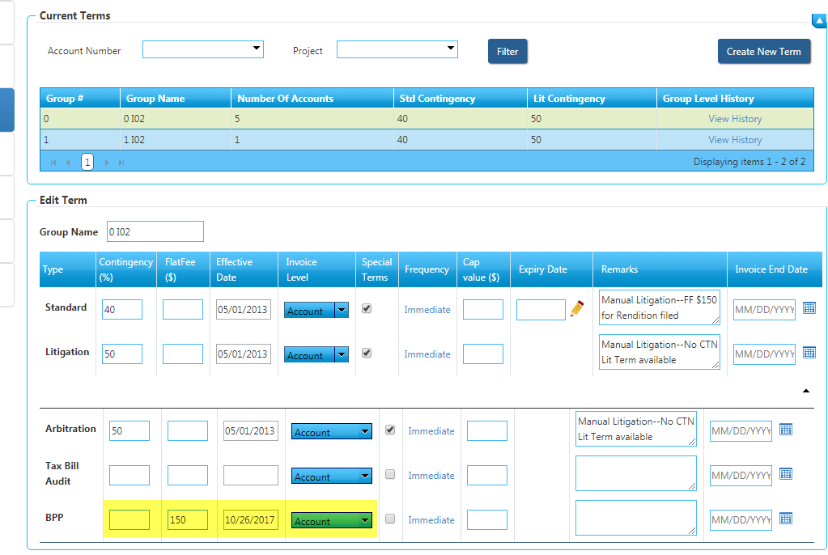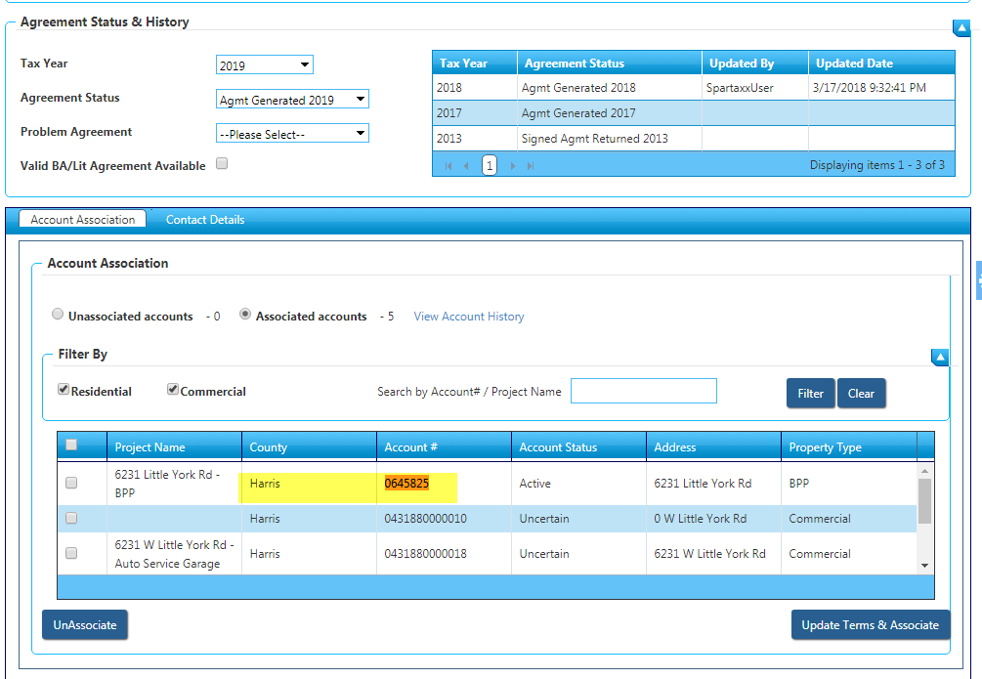

Flat Fee Terms - Term Level: -
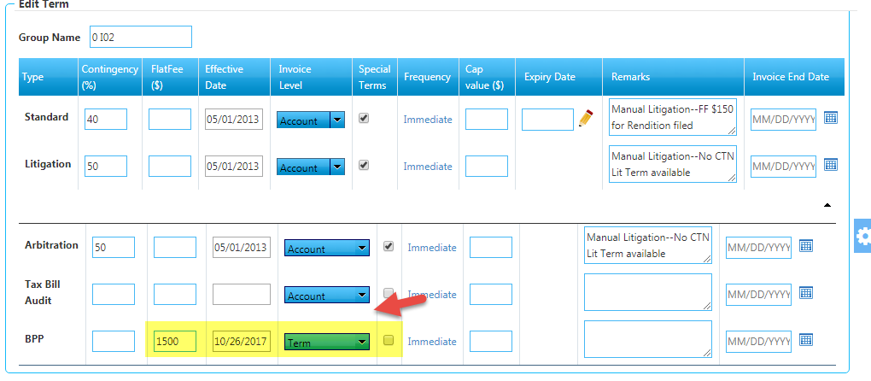
OCA Renders BPP accounts: -
We have a check box option to check if OCA have renders the BPP account at account details tab in spartaxx.
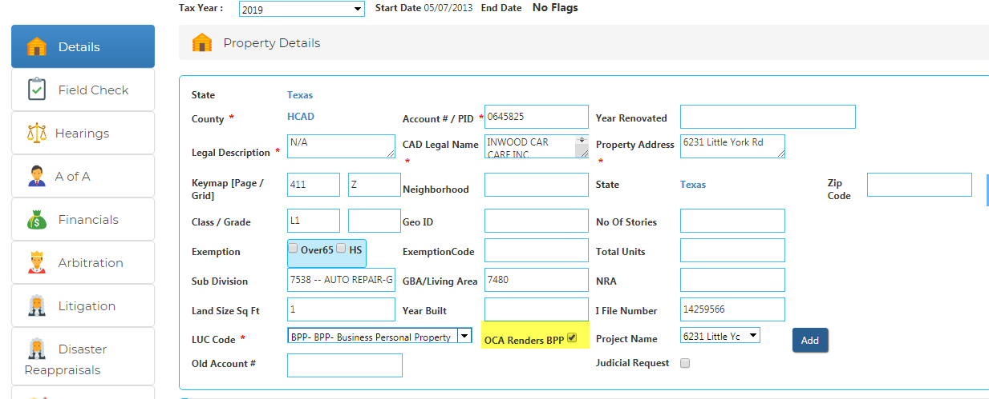
If we do check the check box and save the account, it will be queued Task allocation BPP Rendition Entry Queue.
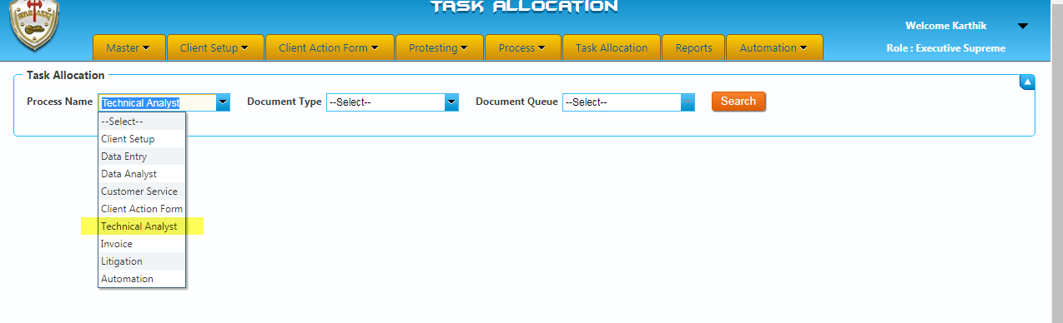
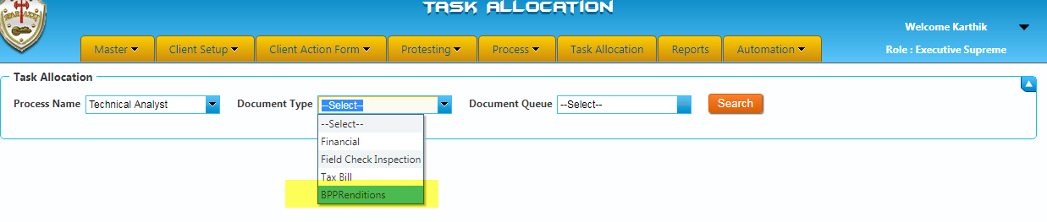
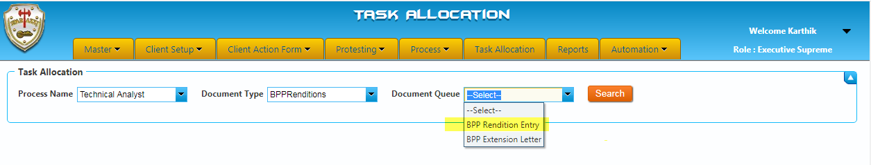
Task Allocation Assigning: -
We can allocate the files from BPP Rendition Entry queue to TA users. Since, TA users only have the access the BPP Entries.
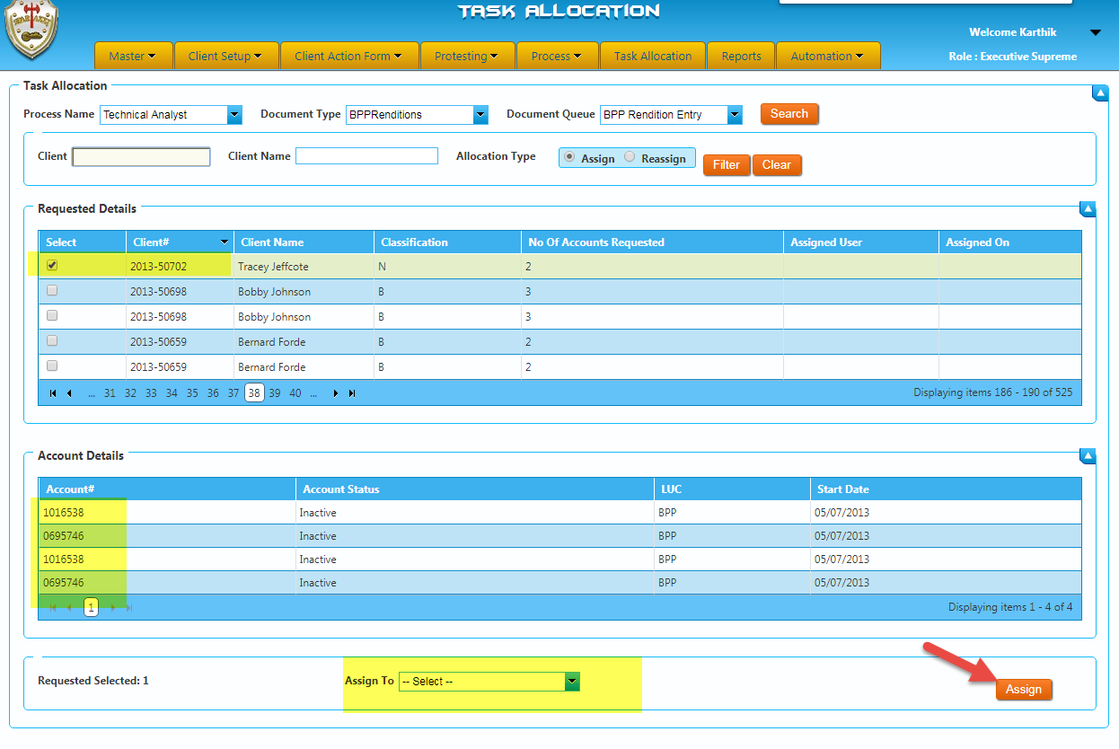
User Entry: -
TA users will have the allocated files under their respective user TA BPP queue.
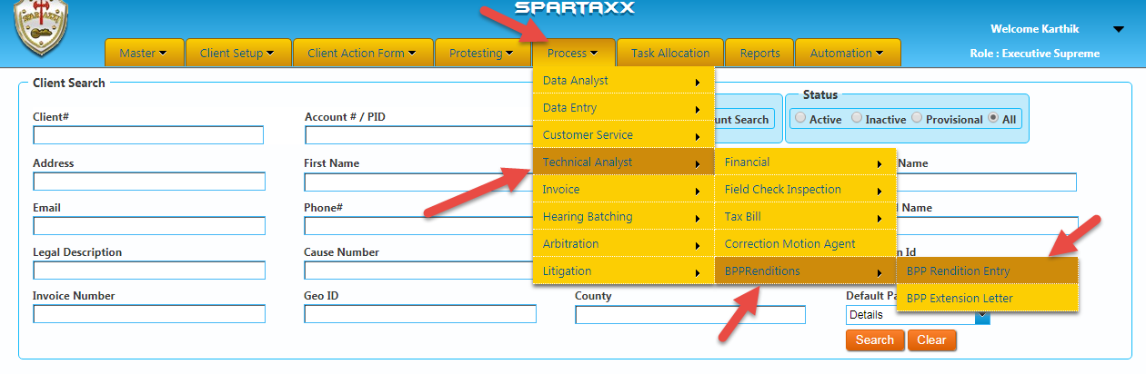

Users will have an option that “BPP processed date” filed while checking the assigned account in respective user BPP Entry queue.
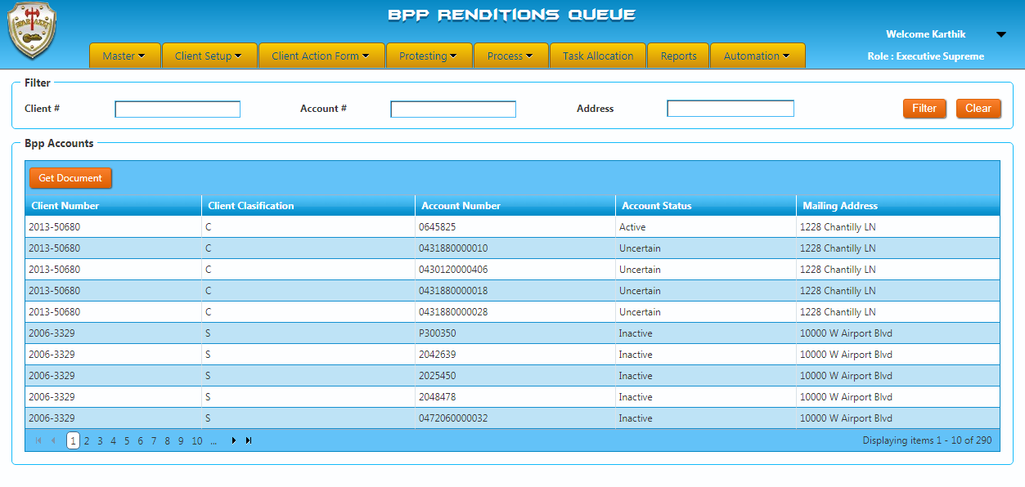
Whereas, users can see the financial information of the account and should enter the “BPP processed date” as current date while saving and clicking submit button.
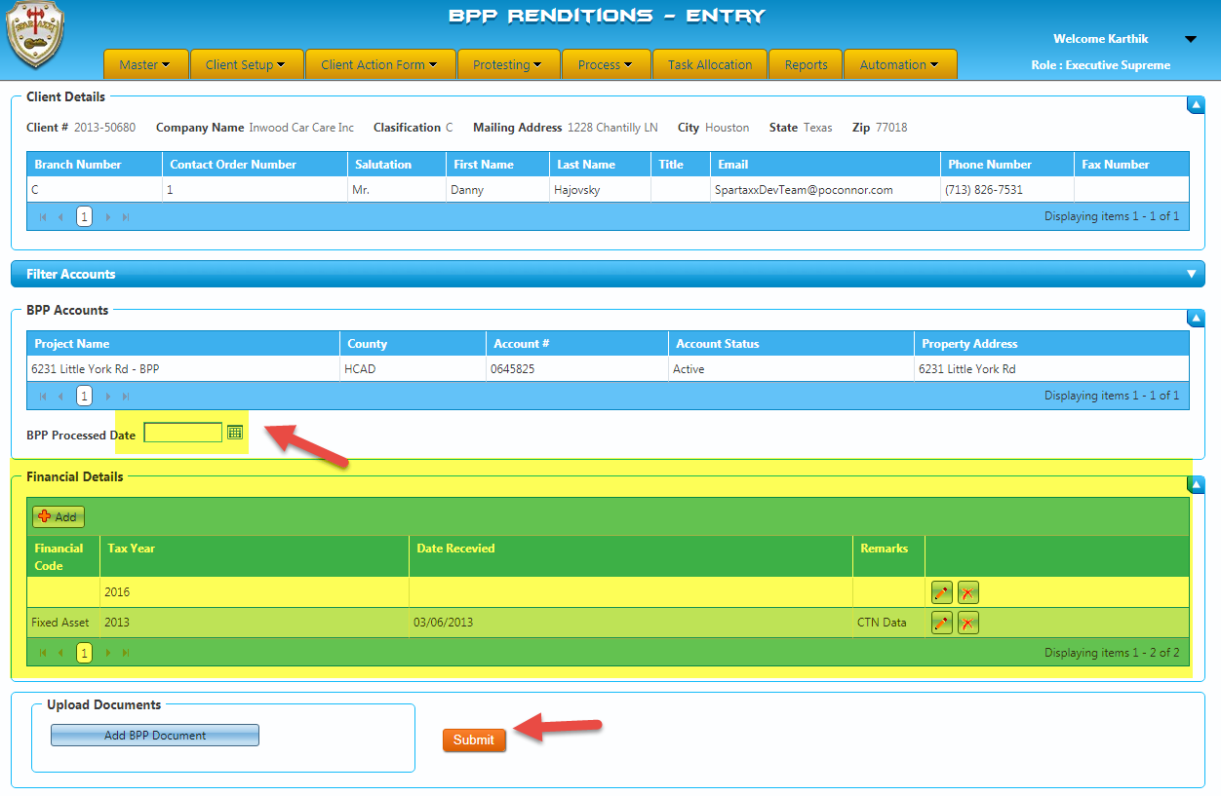
Once after user submit the account, it will be queued in BPP Invoicing Queue.

BPP Invoice Queue: -
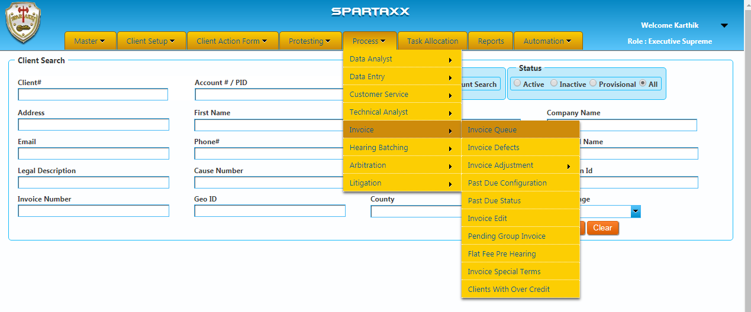
Account Queued: -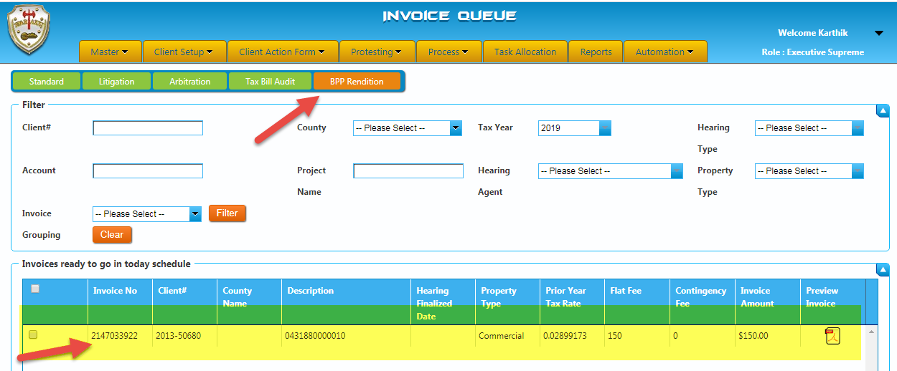
User should select the account by checking the check box of the account and send the invoice from queue by clicking the “Send invoice Now” button at the bottom of the page. Whereas, user can also preview the invoice copy which is being send to client.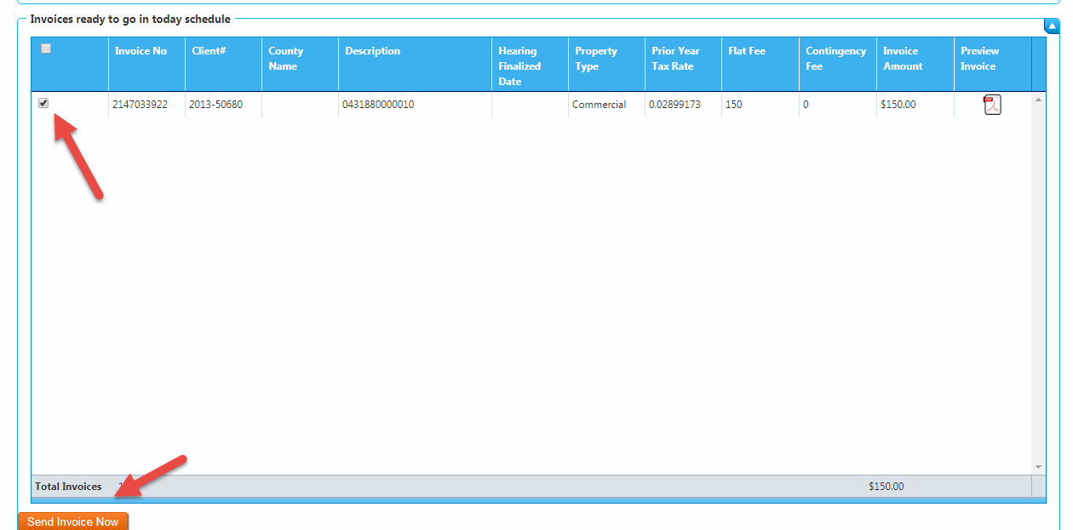
Preview Invoice copy: -
- Preview invoice copy is a mandatory program, before sending the invoice from BPP Rendition invoice queue.
- While previewing invoice copy, if user found any errors in the invoice can be rectified at the invoice queue itself.
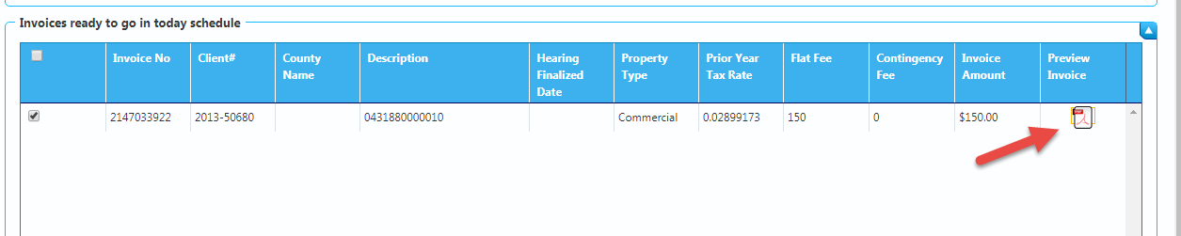
Account Level Invoice Copy: -
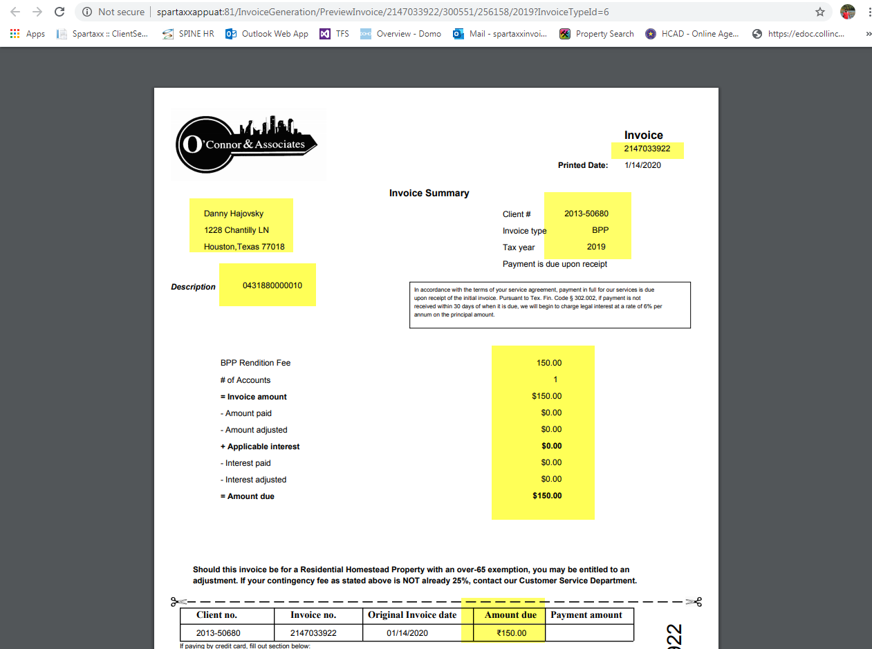
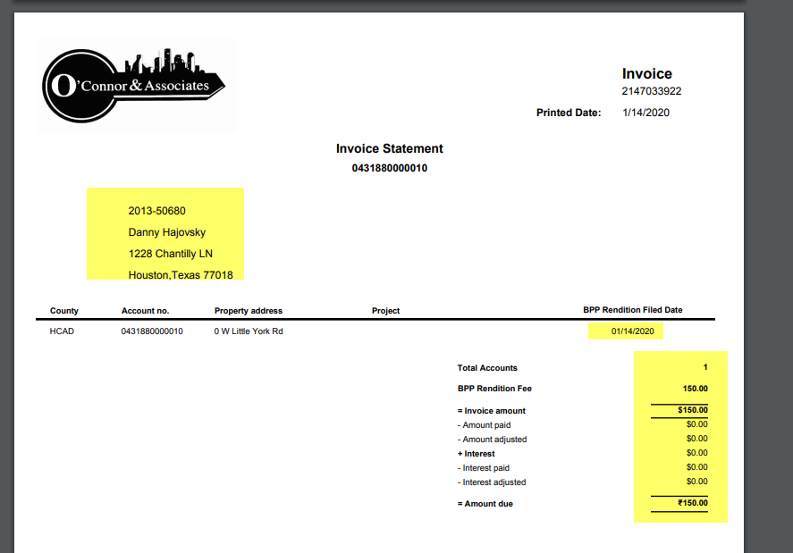
Term Level Invoice Copy: -
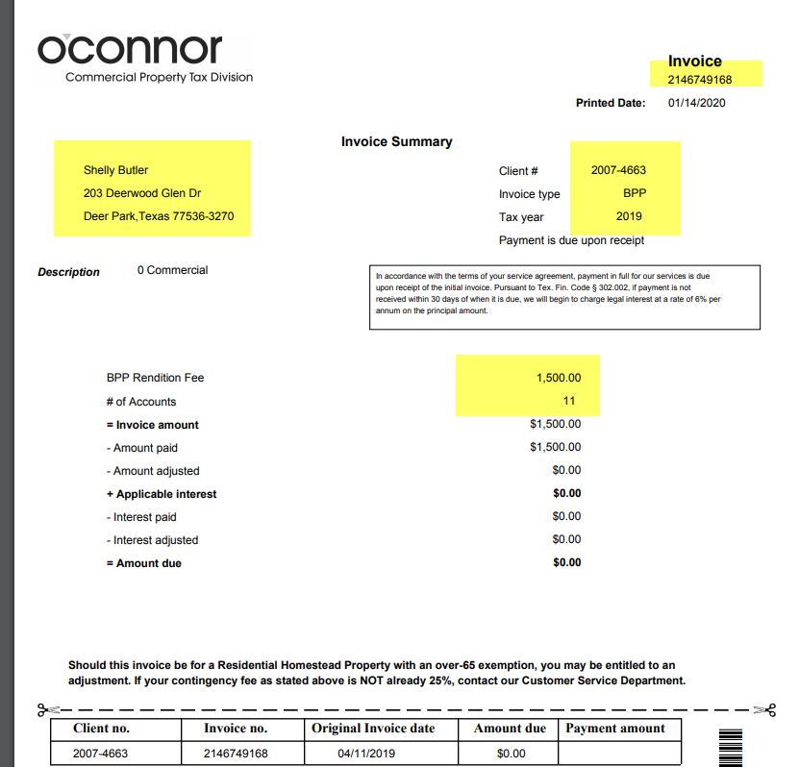
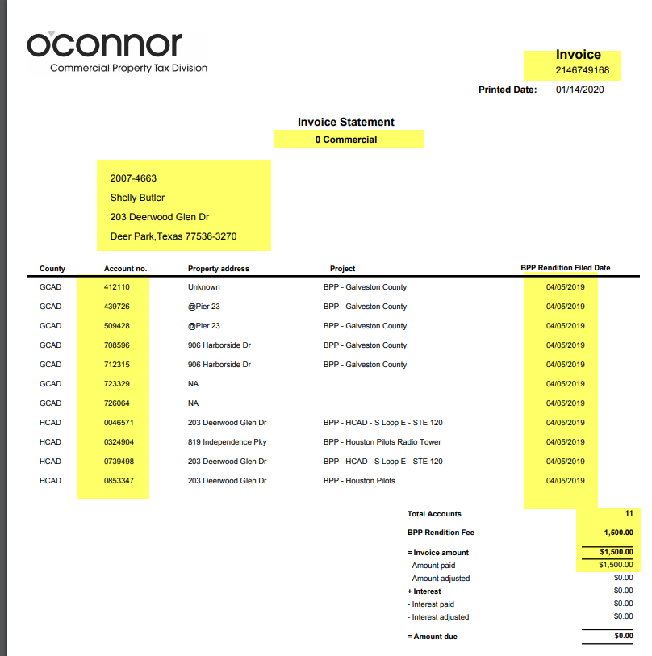
- After sent the invoice from BPP Rendition Invoice queue which will be queued in Corrqueue.
- Corrqueue process will be handled by programming team, they have an invoice service will be having scheduled run at EOD on daily basis.
- Once, corrqueue service run completed all the invoice will be reached to the client based on the delivery method preferred by the client.
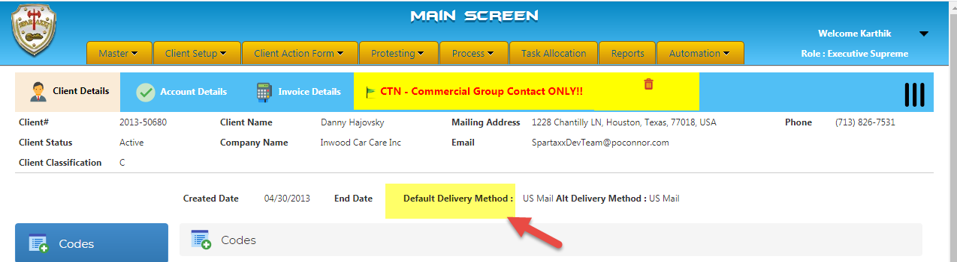
Also, we do double check with list that had a flat fee for each account should be validated from corrqueue invoice list. (Houston Spread Sheet VS Corrqueue list)
After the validation done on each account invoice, we need to give confirmation to programming team to start the service for BPP Invoices.

